Heilongjiang Province, Yichun City– Event Announcement

Event Introduction:

The 2025-2026 Yichun International Ice Dragon Boat Invitational Tournament is set to kick off dynamically in Tangwang County, Yichun City, Heilongjiang Province, from December 26 to 28, 2025. As the core ice and snow experience area of Yichun, known as "China's Forest Capital", Tangwang County is based on the ultimate ice and snow resources at 47°N latitude, integrating the speed and passion of ice dragon boating into the vast forest sea. During the tournament, athletes and spectators will experience the healing texture and northern border enthusiasm of "Ice and Snow Forest · Fairy Tale Tangwang" firsthand, embarking on an exclusive winter ice and snow adventure.

Race Time：
December 26-28, 2025

Competition Site :
Ice Surface Of the Natural Oxygen Bar River Section, Tangwang Country, Yichun

Competition Scale：
Open Group: 4 international teams, 18 China teams

Competition Events：
Open Group: 12-person ice dragon boat 200m straight race， 5-person ice dragon boat 100m straight race， 12-person ice dragon boat 400 drift race
Local Group: 12-person ice dragon boat 200m straight race， 5-person ice dragon boat 100m straight race， 4-person team dragon boat 100m straight race

Event Activities：
During the competition, there will be parades, indoor evening event, out door bonfire parties and other activities.

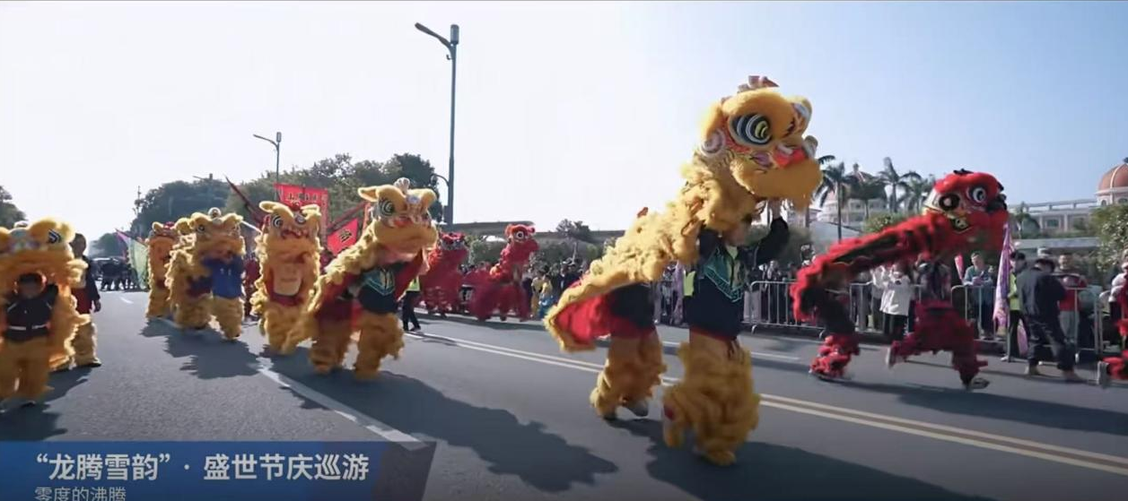
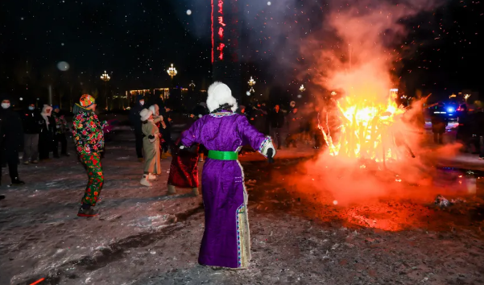

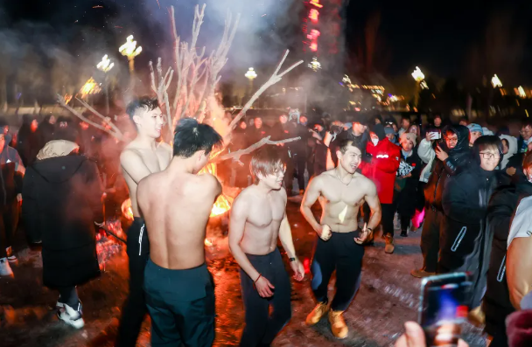

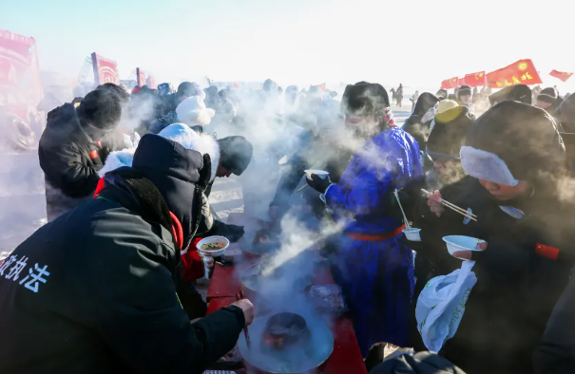

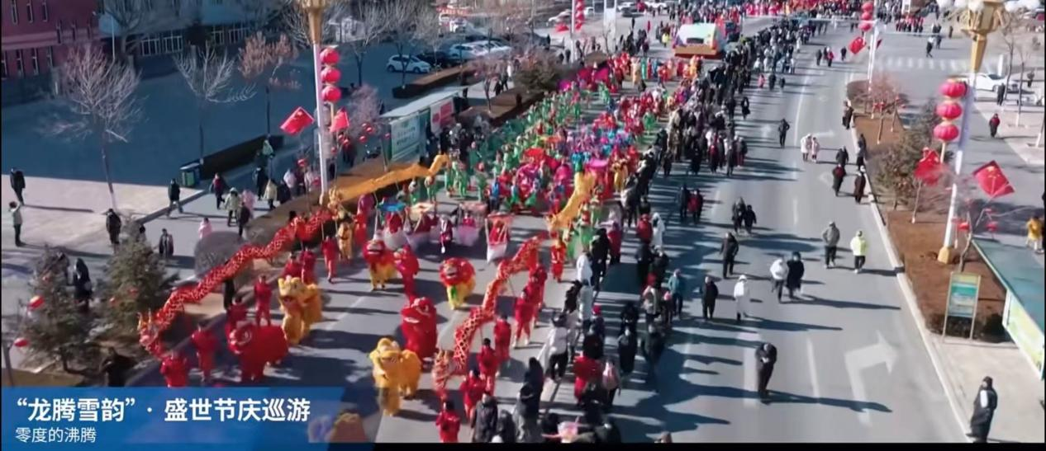

Transportation Methods：
Yichun Lindu Airport (IATA: LDS, ICAO: ZYLD) is located in Lindu Village, Yilin Management Institute, Yimei District, Yichun City, Heilongjiang Province, 9 kilometers away from the downtown area of Yichun. It is a Class 4C domestic regional airport.
We will arrange pick up and drop off once each team from the airport and it will take around 1.5 to 2 hour ride to Tangwang County



Catering & Accommodation：
Tangwang Country Jiuxin Shanzhen





Tourism & Entertainment：
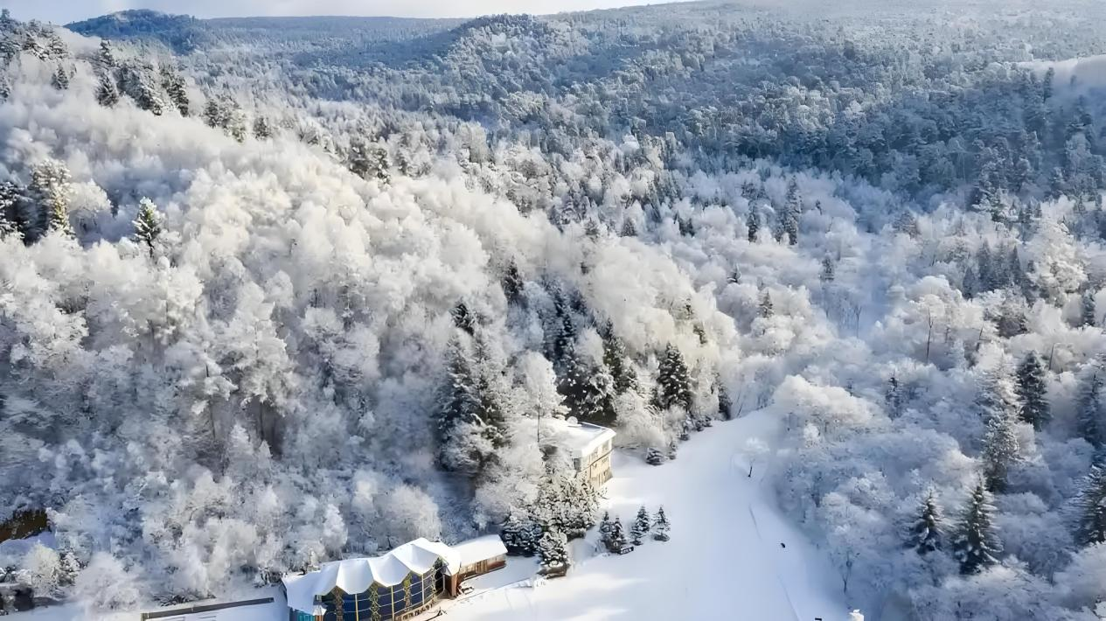

Fantastic rime scenery
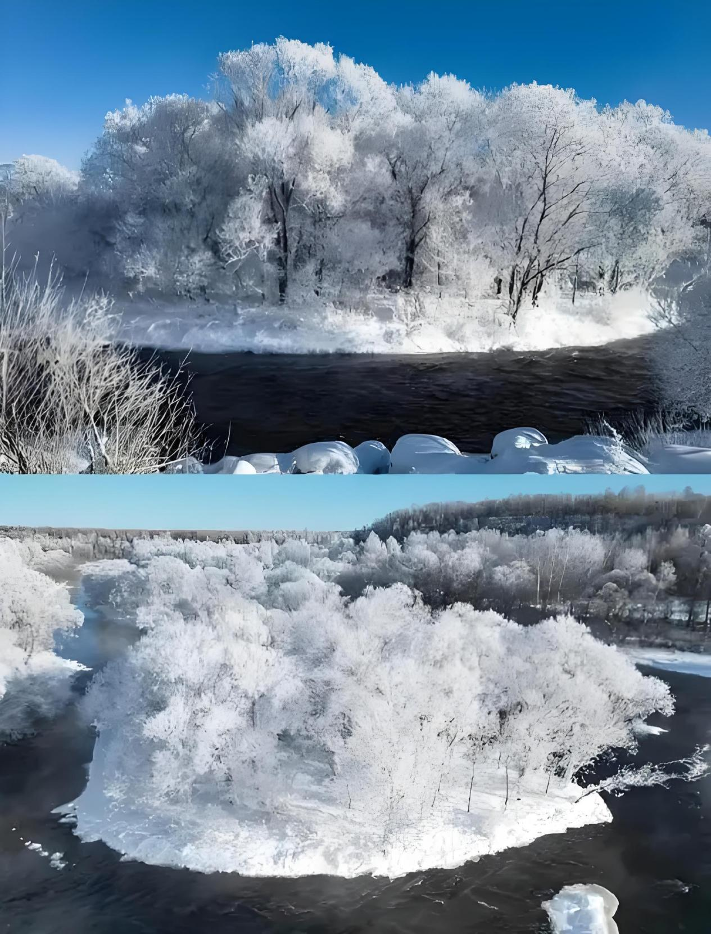
Snowfield secret land
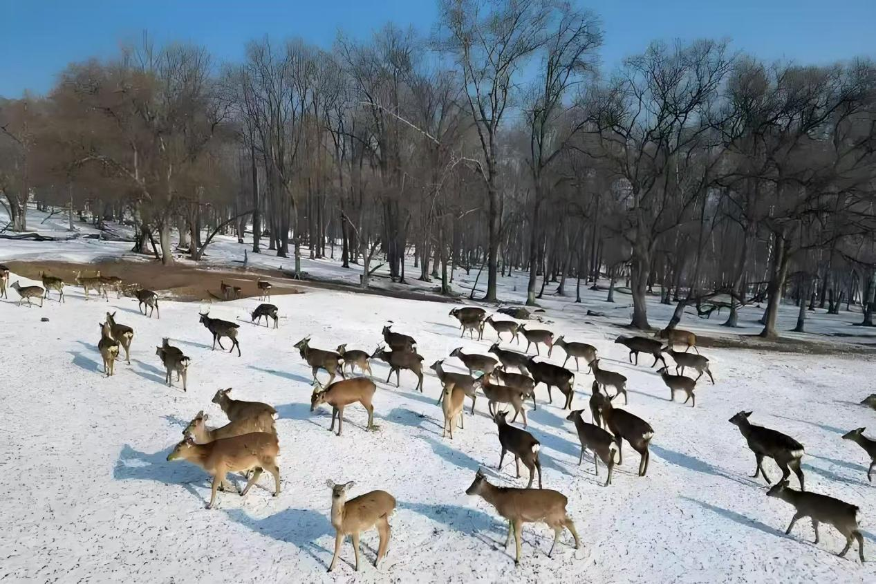
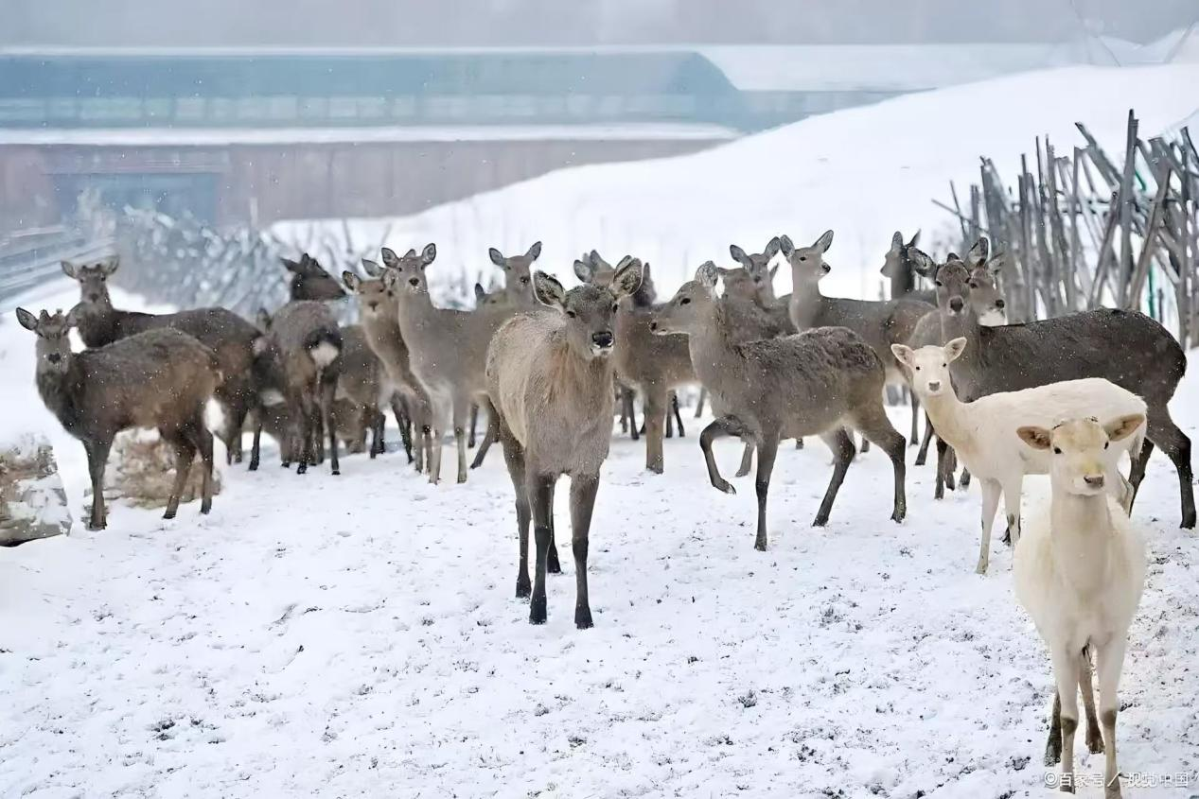
Deer garden.


Local Specialty Cuisine：
Northeast-style pork feast


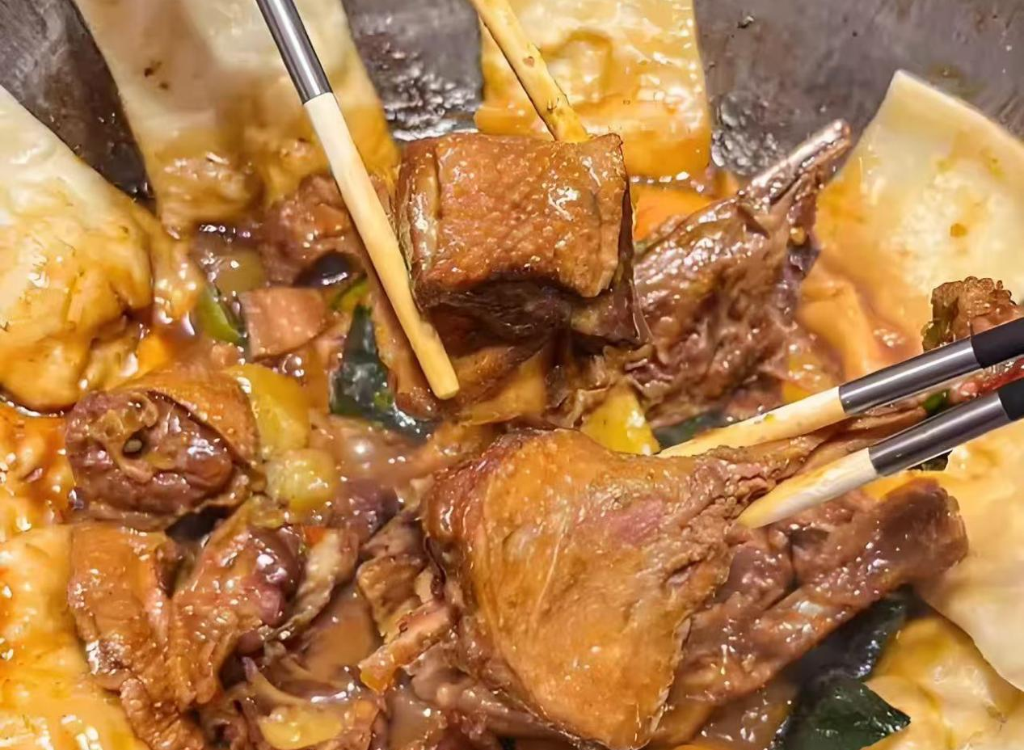
Meixi "Sanguliu" blood sausage

Iron pot stewed goose 

Mushroom stewed chicken

Weather Forecast：
In January 2026, the temperature will be relatively low, with an average daily temperature of -30℃~-15℃. The minimum temperature may drop to -38℃ in some periods, and snowfall may occur. The wind force is mostly Level 1-3.

Dressing Suggestions:
Upper body: It is recommended to wear thick and warm clothes such as cotton-padded clothes, winter coats, leather jackets, thick woolen coats and down jackets.
Lower body: You can choose fleece-lined jeans, thick woolen pants or thermal pants to keep your legs warm.
Accessories: Match with hats, thick gloves, fleece-lined scarves and snow boots. Prepare warm baby patches for the competition and stick them on the inner layer of clothes to avoid frostbite caused by prolonged exposure.

